**IN ACCORDANCE WITH S.C CODE § 41-1-110, THIS HANDBOOK IS NOT AN EXPRESS OR IMPLIED CONTRACT OF EMPLOYMENT.**

**EMPLOYMENT WITH JW ALUMINUM IS AT-WILL.**

**Table of Contents**

1 Introduction: The Code of Conduct 3

2 Message from the CEO 4

3 Health and Safety 5

3.1 Drug & Alcohol-Free Workplace 7

3.2 Workplace Security 7

3.3 Human Rights 8

3.4 Harassment & Bullying Free Workplace 8

3.5 Worker’s Rights 8

3.6 Indigenous Peoples Rights 8

4 Business Integrity 9

4.1 Legal Compliance 9

4.2 Supplier Code of Conduct and Responsible Sourcing 9

4.3 Anti-Corruption and Bribery 10

4.4 Vendor Gifts 11

4.5 Conflicts of Interest 11

4.6 Confidential Information 12

4.7 Training and Communication 12

4.8 Record keeping 12

4.9 Teammate Responsibilities 12

5 Requests for Information, Complaints and Grievances 13

5.1 Whistleblowing 13

5.2 Open-Door Policy 13

5.3 External Inquiries 13

6 Environmental Management System 14

7 Quality Management System 15

8 Appendix A 16

# Introduction: The Code of Conduct

JW Aluminum expects all teammates to conduct themselves and company business in a manner that reflects the highest standards of ethical conduct, and in accordance with all federal, state, and local laws and regulations. The company’s high standards are a competitive advantage and help us attract and retain world-class teammates, customers, and stakeholders.

To ensure JW Aluminum teammates understand our expectations regarding the company’s WIN culture, policies, and procedures we educate teammates and provide transparency to our Code of Conduct.

The Code of Conduct and Ethics (the “Code of Conduct” or the “Code”) sets forth the expectations of how we live WIN, conduct business, and interact with each other and our business partners. We are a business of businesspeople committed to a culture of teamwork and continuous improvement to Secure the Future for teammates and customers. The Code applies to all teammates, officers and directors of JW Aluminum.

At the cornerstone of JW Aluminum’s WIN Culture is our Vision Statement: By Developing our People, Improving our Processes, and Delivering Value to the Marketplace Safely, the JW Aluminum team can achieve our Vision to become The Leading Aluminum Rolled Products Company in the World.

JW Aluminum’s Code of Conduct directly reflects these cultural principles and provides a framework for behavior expectations for all teammates at every level, specifically regarding social, environmental and governance principles. It sets forth the expectations of how we live our WIN culture, conduct business, and interact with each other, our business partners, and the environment.

Company policies related to the Code of Conduct are located on SharePoint on the Human Resources page, under Policies.

# Message from the CEO

At JW Aluminum, we have a strong commitment to Living WIN and using our Target Behaviors to treat each other, customers, stakeholders, and our planet, with respect. Our company Vision and Target Behaviors are the very foundation of this Code of Conduct.

Our Code of Conduct translates JW Aluminum’s Vision and Target Behaviors into action. It is our responsibility to speak up whenever we encounter behavior or actions that violate the Code of Conduct. In the Code of Conduct, we have a range of expectations, regarding how we interact with each other and our stakeholders. We will always strive to ensure our workplaces are safe and inclusive, allowing everyone to work to their full potential without fear of harassment or discrimination.

Whenever in doubt, refer to the Code, JW Aluminum policies, or contact any of our teammates –   
your supervisor or team leader, plant leader, or your organization’s human resources partner – any teammate in the organization for assistance.

That said, if you Live WIN, if you consistently demonstrate our Target Behaviors, you will have very little doubt about how to follow our Code of Conduct. These principles are already in our DNA. Just as we do with WIN, we will continually communicate the principles of our Code of Conduct throughout the organization. Thank you for your commitment and your contributions toward our Vision to become The Leading Aluminum Rolled Products Company in the World and Secure our Future.



# Health and Safety

JW Aluminum proactively protects the health and safety of all team members and visitors by leading a culture of safety focused individuals. We utilize an Occupational Health & Safety Management System as our foundation which ensures ownership and accountability at all levels, providing educational and preventive tools necessary to support our mission.

**JW Aluminum’s Occupational Health and Safety (OH&S) Management System** applies to all teammates and visitors, and includes but not limited to the following:

* Organizational Context
* Leadership and Commitment
* Safety Policy
* Organizational Roles, Responsibilities, and Authorities
* Participation of Teammates and Safety Committees
* OH&S Objectives and Planning
* Actions to Address Risks and Opportunities
* Software for Incident and Near Miss Reporting, Root Cause Analysis, and Corrective Actions
* Control Documents
* Emergency Preparedness and Response
* Monitoring, Measurement, Analysis, and Performance Evaluation
* Internal Audit and Management Review
* Internal and External Communication

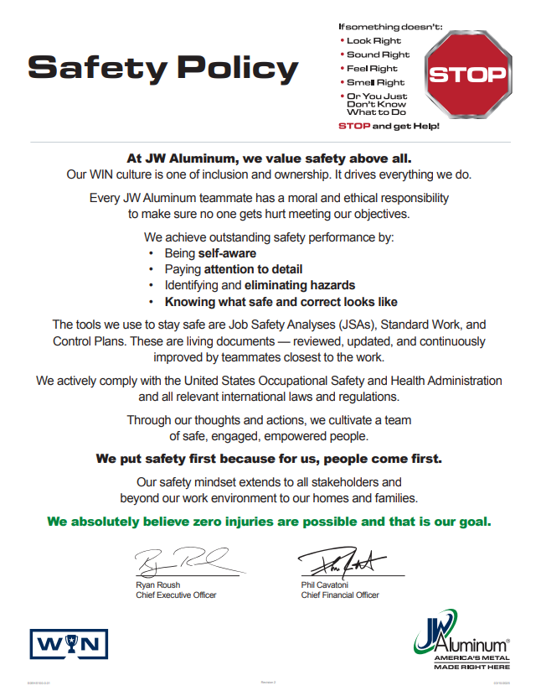

## Drug & Alcohol-Free Workplace

It is the policy of JW Aluminum to maintain a drug- and alcohol-free work environment that is safe and productive for teammates and others having business with the company.

The unlawful use, possession, purchase, sale, distribution, or being under the influence of any illegal drug and/or the misuse of legal drugs while on company or client premises or while performing services for the company is strictly prohibited. JW Aluminum also prohibits reporting to work or performing services under the influence of alcohol or consuming alcohol while on duty or during work hours. In addition, the JW Aluminum prohibits off-premises abuse of alcohol and controlled substances, as well as the possession, use, or sale of illegal drugs, when these activities adversely affect job performance, job safety, or the Company’s reputation in the community.

## Workplace Security

JW Aluminum is committed to providing a safe, violence-free workplace for our teammates. We have zero tolerance for violence. Due to this commitment, we discourage teammates from engaging in any physical confrontation with a violent or potentially violent individual or from behaving in a threatening or violent manner. Threats, threatening language, or any other acts of aggression or violence made toward or by any teammate will not be tolerated. A threat may include any verbal or physical harassment or abuse; attempts to intimidate others; menacing gestures; stalking; or any other hostile, aggressive, and/or destructive actions taken for the purposes of intimidation.

All JW Aluminum teammates bear the responsibility of keeping our work environment free from violence or potential violence. Any teammate who witnesses or is the recipient of violent behavior should promptly inform their supervisor, manager, or HR department. All threats will be promptly investigated. No teammate will be subject to retaliation, intimidation, or discipline as a result of reporting a threat in good faith under this guideline.

JW Aluminum prohibits the possession of weapons on its property at all times, including our parking lots or company vehicles. Additionally, while on duty, teammates may not carry a weapon of any type. Weapons include, but are not limited to, handguns, rifles, automatic weapons, knives that can be used as weapons (excluding pocketknives, utility knives, and other instruments that are used to open packages or cut string and for other miscellaneous tasks), martial arts paraphernalia, stun guns, and tear gas. Any Teammate violating this policy is subject to discipline up to and including dismissal for the first offense.

The company reserves the right to inspect all belongings of Teammates on its premises, including packages, briefcases, purses and handbags, gym bags, and personal vehicles on company property. In addition, JW Aluminum may inspect the contents of lockers, storage areas, file cabinets, desks, and workstations at any time and may remove all company property and other items that are in violation of company rules and policies.

You are encouraged to report any incident that may involve a violation of our policies that are designed to provide a comfortable and safe workplace environment. Concerns may be presented to your supervisor, or a designated member of our management team.

All reports will be investigated, and information will be kept confidential, except where there is a need to know to effectuate a solution to the problem.

## Human Rights

JW Aluminum is dedicated to promoting respect for fundamental human rights wherever it operates and encourages consideration of these principles by others where it has an influence, particularly contractors, suppliers and all other entities and individuals with whom we have a business relationship. JW Aluminum is committed to ensuring all fundamental human rights practices in accordance with international best practices and expects teammates to maintain an environment that reflects respect for human rights and is free from all forms of discrimination and harassment. JW Aluminum is committed to a zero-tolerance approach to any form of modern slavery.  
  
Also, JW Aluminum complies with United States Federal and State Laws, as well as the International Labor Organization guidelines regarding remuneration, working times, family leave, disciplinary practices, and Freedom of Association.

We believe these standards are fundamental to our future operations as well as the sustainability of our surrounding communities. The Corporate Policy Manual provides policy details for the following topics:

It is every teammate’s responsibility to follow this code to maintain an environment that reflects respect for human rights and is free from all forms of discrimination and harassment.

## Harassment & Bullying Free Workplace

JW Aluminum is committed to a work environment in which all individuals are treated with respect and dignity. Everyone has the right to work in a professional atmosphere that promotes equal employment opportunities and prohibits unlawful discriminatory practices, including harassment. Therefore, JW Aluminum expects that all relationships among persons in the workplace will be business-like and free of bias, prejudice, and harassment.

JW Aluminum is committed to providing all teammates with a healthy and safe work environment. JW Aluminum will ensure that procedures exist to allow complaints of harassment and bullying to be dealt with and resolved within JW Aluminum, without limiting any person’s entitlement to pursue resolution of their complaint with the relevant statutory authority. JW Aluminum is committed to the elimination of all forms of harassment and bullying.

## Worker’s Rights

JW Aluminum complies with United States Federal and State Laws, as well as the International Labor Organization guidelines regarding remuneration, working times, family leave, disciplinary practices, and Freedom of Association. Details about these requirements and best practices can be found in JW Aluminum’s Corporate Policy Manual.

## Indigenous Peoples Rights

Although JW Aluminum does not operate on any Native American Reservation or Tribal Land, it believes in creating a culture of respect for the indigenous people of the world. It observes all applicable regulations regarding Native American rights within its local communities. JW Aluminum understands the significance Native American, and groups found within the United States and adheres to the recommendations put in place by the Indiana Native American Indian Affairs Commission (INAIAC), The American Declaration on the Rights of Indigenous Peoples, and the US Agency for International Development (USAID) regarding Free and Prior Informed Consent, Resettlement standards, and cultural and sacred heritage. Additionally, JW Aluminum is consistent with international standards including ILO Convention 169 and the UN Declaration on Rights of Indigenous Peoples.

# Business Integrity

## Legal Compliance

The first pillar of operating with business integrity is to maintain legal compliance company-wide.

As a small, privately owned company, we leverage various outside resources to maintain awareness of and comply with the laws, regulations, and expectations for all aspects of our business. Teammates leading a functional area work with legal and regulatory subject matter experts to maintain compliance. Findings and updates are formally reported to the Company’s executive leadership team in accordance with milestones specific to each discrete project or review. Teammates are kept up to date on non-proprietary compliance performance via onboarding, participation in regulatory reviews and internal communication vehicles.

Additional documentation regarding the company’s regulatory compliance is referenced on SharePoint on the ESG page.

## Supplier Code of Conduct and Responsible Sourcing

JW Aluminum has documented a Supplier Code of Conduct and a Responsible Sourcing Policy.   
Our Supplier Code of Conduct reflects our company culture, values, and operating principles we share with our suppliers. JW Aluminum partners with suppliers who work with us as a team, communicate openly, and meet their commitments.

In terms of Governance, our Supplier Code of Conduct expects suppliers to fully comply with all applicable laws and regulations including but not limited to the environment, employment and labor, human rights, health and safety, safe workplace practices, and competition/anti-bribery.

In terms of human rights, we expect suppliers to holistically show respect for all teammates and members of their local communities through fair and equal treatment, diversity, and inclusion. Also, the Supplier Code of Conduct also requires that suppliers certify they are not knowingly sourcing conflict minerals and continually monitor its supply chain to prevent sourcing materials from known human rights offenders.

With respect to the environment, we value suppliers who not only are in full compliance with environmental laws, but also demonstrate how their companies minimize adverse environmental impacts and leverage conservation measures.

The Responsible Sourcing Policy outlines in more detail the ESG expectations we have for our suppliers and asks suppliers to sign a statement of responsibility.

## Anti-Corruption and Bribery

JW Aluminum has a zero-tolerance policy for bribery and corruption.

As a company, we believe in acting professionally, fairly, and with integrity in all business dealings. JW Aluminum expects all teammates to conduct themselves in a manner that reflects the highest standards of ethical conduct, and in accordance with all federal, state, and local laws and regulations. This includes avoiding both real and potential conflicts of interest.

JW Aluminum is committed to implementing and enforcing systems that ensure bribery and corruption is prevented in its business operations, JW Aluminum ensures the compliance of political and charitable contributions, vendor gifts, facilitation payments, and kickbacks. We believe in acting professionally, fairly, and with integrity in all business dealings.

All teammates and suppliers must:

* Carry out business in a legal, transparent, and ethical way.
* Obey applicable laws and corresponding regulations governing fraud, bribery, and corruption.
* Commit to the principles of fair competition and comply with the antitrust and fair competition laws of the United States.
* Prevent, detect, and report bribery and other forms of corruption.
* Avoid any activities that could lead to, or imply, a breach of this Anti-Corruption policy.
* Notify the Chief Financial Officer if there is reason to believe or suspect that an instance of bribery or corruption has occurred or will occur in the future.
* Notify the Chief Financial Officer as soon as possible if they are offered a bribe by anyone, if they are asked to make one, if they suspect that they may be bribed or asked to make a bribe, or if they have reason to believe that they are a victim of another corrupt activity.

This policy applies to all teammates, consultants, contractors, interns, or any other persons associated with JW Aluminum (including third parties), no matter where they are located (within or outside of the US). The policy also applies to Officers, Trustees, Board, and/or Committee members at any level.

In the context of this policy, third-party refers to any individual or organization JW Aluminum meets and works with. It refers to actual and potential clients, customers, suppliers, distributors, business contacts, agents, advisers, and government and public bodies – this includes their advisors, representatives and officials, politicians, and public parties.

Any arrangements JW Aluminum makes with a third party is subject to clear contractual terms, including specific provisions that require the third party to comply with minimum standards and procedures relating to anti-bribery and corruption.

## Vendor Gifts

JW Aluminum recognizes that gifts can be a normal and appropriate gesture of hospitality and goodwill. JW Aluminum also recognizes that the practice of giving and receiving business gifts varies between countries, regions, cultures, and religions, so definitions of what is acceptable and not acceptable will inevitably differ for each. As good practice, gifts given and received should always be disclosed to the Chief Financial Officer. Gifts from suppliers should always be disclosed. The intention behind a gift being given/received should always be considered. If there is any uncertainty, the advice of the Chief Financial Officer should be sought.

## Conflicts of Interest

JW Aluminum expects all teammates to conduct themselves and company business in a manner that reflects the highest standards of ethical conduct, and in accordance with all federal, state, and local laws and regulations. This includes avoiding real and potential conflicts of interest.

Exactly what constitutes a conflict of interest, or an unethical business practice is both a moral and a legal question. JW Aluminum recognizes and respects the individual teammate’s right to engage in activities outside of employment which are private in nature and do not in any way conflict with or reflect poorly on the company.

It is not possible to define all the circumstances and relationships that might create a conflict of interest. If a situation arises where there is a potential conflict of interest, the teammate should discuss this with a manager for advice and guidance on how to proceed. The list below suggests some of the types of activity that indicate improper behavior, unacceptable personal integrity, or unacceptable ethics:

* Simultaneous employment by another firm that is a competitor of or supplier JW Aluminum.
* Carrying on company business with a firm in which the teammate, or a close relative of the teammate, has a substantial ownership or interest.
* Holding a substantial interest in, or participating in the management of, a firm to which the company makes sales or from which it makes purchases.
* Borrowing money from customers or firms, other than recognized loan institutions, from which our company buys services, materials, equipment, or supplies.
* Accepting substantial gifts or excessive entertainment from an outside organization or agency.
* Speculating or dealing in materials, equipment, supplies, services, or property purchased by the company.
* Participating in civic or professional organization activities in a manner that divulges confidential company information.
* Misusing privileged information or revealing confidential data to outsiders.
* Using one’s position in the company or knowledge of its affairs for personal gains.
* Engaging in practices or procedures that violate antitrust laws, commercial bribery laws, copyright laws, discrimination laws, campaign contribution laws, or other laws regulating the conduct of company business.

## Confidential Information

The protection of confidential business information and trade secrets is vital to the interests and success of JW Aluminum. Confidential information is all information disclosed to or known by you because of employment with the company that is not generally known to people outside the company about its business.

A teammate who improperly uses or discloses trade secrets or confidential business information will be subject to disciplinary action up to and including termination of employment and legal action, even if he or she does not actually benefit from the disclosed information.

All inquiries from the media must be referred to the Director of Communications.

This provision is not intended to, and should not be interpreted to, prohibit teammates from discussing wages and other terms and conditions of employment if they choose.

## Training and Communication

JW Aluminum’s anti-bribery and corruption policy and zero-tolerance attitude will be clearly communicated to all suppliers, contractors, business partners, and any third parties at the outset of business relations, and as appropriate thereafter.

## Record keeping

JW Aluminum will keep detailed and accurate financial records and will have appropriate internal controls in place to act as evidence for all payments made. The Entity will declare and keep a written record of the amount and reason for hospitality or gifts accepted and given and understand that gifts and acts of hospitality are subject to managerial review.

## Teammate Responsibilities

Teammates of JW Aluminum must ensure that they understand and comply with the information contained within this agreement, and with any training or other information provided related to anti-bribery and corruption information. All teammates and those under JW Aluminum’s control are equally responsible for the prevention, detection, and reporting of bribery and other forms of corruption. They are required to avoid any activities that could lead to, or imply, a breach of this Anti-Corruption policy.

If there is reason to believe or suspect that an instance of bribery or corruption has occurred or will occur in the future that breaches this policy, the Chief Financial Officer must be notified. If any teammate breaches this policy, they will face disciplinary action and could face dismissal for gross misconduct.

Teammates must tell the Chief Financial Officer as soon as possible if they are offered a bribe by anyone, if they are asked to make one, if they suspect that they may be bribed or asked to make a bribe in the near future, or if they have reason to believe that they are a victim of another corrupt activity.

# Requests for Information, Complaints and Grievances

## Whistleblowing

If a teammate suspects that there is an instance of ethical violation activities occurring in relation to JW Aluminum, they are encouraged to raise concerns at an early stage. If they are uncertain about whether a certain action or behavior can be considered an ethical concern, they should speak to the appropriate manager, director, Human Resources or an Executive.

JW Aluminum encourages reporting of all perceived incidents of violation of the Code of Conduct or ethics. JW Aluminum will promptly and thoroughly investigate such reports. JW Aluminum also prohibits any retaliation against an individual who, in good faith, reports or participates in the investigation of an ethical concern.

## Open-Door Policy

In our Corporate Policy Manual, outlines the company’s Open-Door policy. We encourage teammates to work with management to address any of their concerns. We are committed to be receptive and fair and give teammates the right to appeal.

## External Inquiries

There are multiple forms on our company website where stakeholders outside of the company can make inquiries. When the forms are submitted, they are automatically electronically directed to a teammate in a department that can address the inquiry or concern. Questions can be directed through the website or to [Questions@JWAluminum.com](mailto:Questions@JWAluminum.com).

# Environmental Management System

JW Aluminum is committed to operating in a way that respects and protects the environment at our locations. We will not compromise our environmental commitment for profit or production. We comply with all applicable laws, policies, and environmental standards, and respond truthfully and responsibly to questions and concerns about our environmental actions and the impact of our operations on the environment.

The company’s Environmental Management System focuses on maximizing resources and mitigating risk through ongoing evaluation, documentation, and prioritization of opportunities to improve the company’s overall environmental performance.

JW Aluminum publishes an annual sustainability report on the company website. The report outlines our ESG performance and impacts.

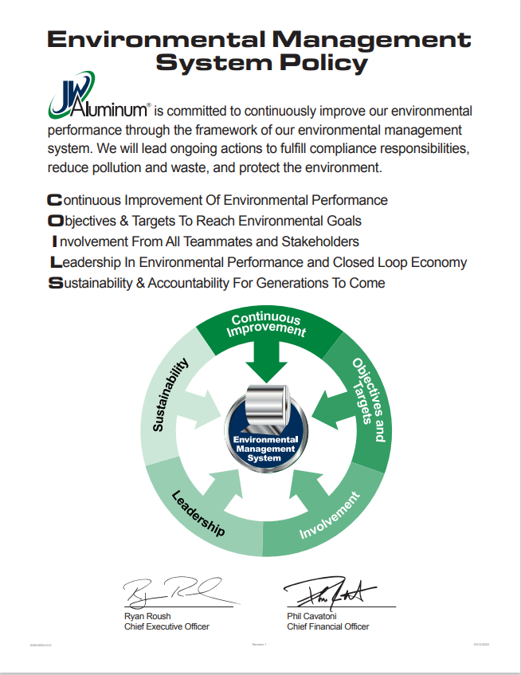

# Quality Management System

At JW Aluminum, the quality of our products is a direct reflection of our commitment to customer service. That’s why we always strive to produce the highest possible quality aluminum designed to fit our customer’s exact needs and specifications. We’ve been able to consistently deliver a rejection rate of less than a fraction of one percent per year.

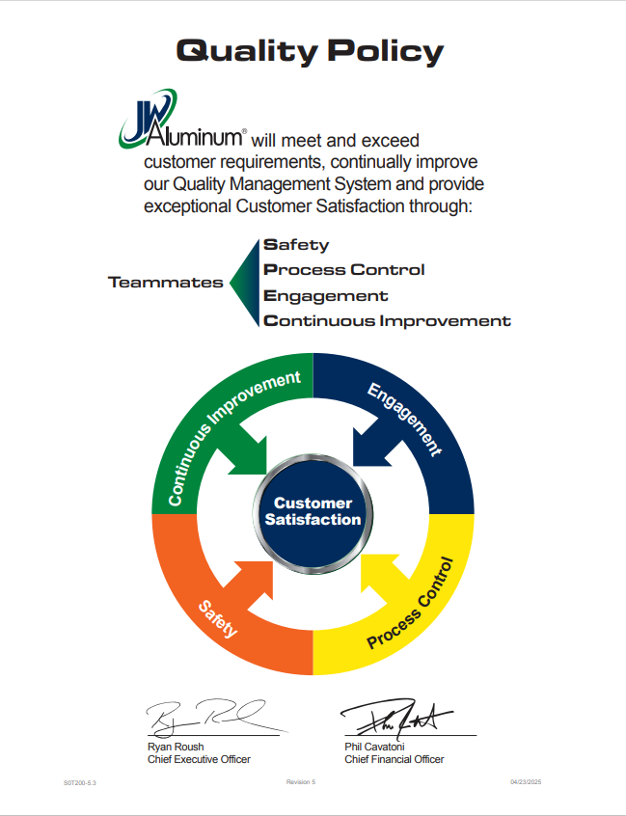

# Appendix A

**Record of Revision**

|  |  |  |
| --- | --- | --- |
| **Revision No.** | **Issue Date** | **Description** |
| 0 | 01/03/2023 | Initial Issuance of Handbook |
| 1 | 12/18/2023 | Added Contact Email |
| 2 | 05/08/2025 | Converted to controlled document. Updated Quality, Safety, and Environmental Policies |